University of Science and Technology Houari Boumediene

First semester Exam

Promo 2023/2024

Topic :

TIC

Information and Communication Technologies

Realized by : Group 7

Maria BEZZAZ Nawel CHELLAH Ahmed FERKANE

Khadidja OULAD SAID Younes BOUGADOUM



Summery

Introduction ........................................................................................2

Google services....................................................................................4

Gmail....................................................................................................6

Maps....................................................................................................8

Calendar............................................................................................10

Chrome..............................................................................................12

Sheets ...............................................................................................15

Meet...................................................................................................17

Classrom.............................................................................................18

Drive...................................................................................................19

Uses of google services.......................................................................20

Microsoft tools .................................................................................22

Word/Excel.........................................................................................24

Powerpoint.........................................................................................25

Publisher.............................................................................................26

Access.................................................................................................27

Azure..................................................................................................29

Onedrive.............................................................................................30

Microsoft teams.................................................................................31

Git/Github..........................................................................................32

Conclusion...........................................................................................35

References.........................................................................................36

1



Introduction to TIC

In the ever-shifting landscape of the 21st century, the rise of Information and Communication Technologies (TIC) has been nothing short of revolutionary, establishing itself as a cornerstone in our digital existence. TIC spans a vast spectrum of technologies, encompassing hardware, software, networks, and an array of digital communication tools. These technological enablers collectively empower individuals, businesses, and entire societies by facilitating the seamless exchange and processing of information.

The evolutionary trajectory of TIC has been transformative, leaving an indelible mark on every facet of our lives. From reshaping the dynamics of interpersonal communication to revolutionizing the operational paradigms of businesses, TIC has become synonymous with progress and connectivity in our contemporary world. As we navigate through the digital era, possessing a profound understanding of TIC is not merely advantageous but indispensable for unlocking its full potential and navigating the complexities of the modern technological landscape.

The relentless march of TIC has precipitated a paradigm shift in the dynamics of connectivity and information exchange. It has transformed communication from a linear process into a dynamic, interconnected web where information flows seamlessly and rapidly.

Businesses of all scales find themselves compelled to adapt and embrace TIC to stay competitive and innovative in an environment where technological advancement is the linchpin of success.

2

Furthermore, the societal ramifications of TIC are monumental. Acting as a catalyst for social change, TIC has obliterated geographical barriers, giving rise to a global community where ideas, cultures, and information converge. The democratization of information has empowered individuals, offering unprecedented access to knowledge and resources, thereby fostering inclusivity on a global scale.

Standing at the crossroads of this digital revolution, the imperative for TIC literacy cannot be overstated. A nuanced understanding of TIC is not only crucial for individuals navigating the complexities of the digital age but also for policymakers shaping the trajectory of technological advancements. It is a tool that empowers us to harness the potential of technology responsibly, ensuring that the benefits of progress are shared equitably and the pitfalls are mitigated effectively.

In conclusion, the dynamic evolution of Information and Communication Technologies has permeated every facet of our existence, ushering in profound changes in communication, business operations, and global interaction. Embracing TIC with a well-informed perspective is not just a survival strategy in the digital landscape; it is the key to unlocking limitless opportunities for innovation, progress, and connectivity in the 21st century.

3



Google Services

4



Google Services

In the ever-expanding digital landscape, Google Services has evolved into an indispensable suite, transforming the way we communicate, navigate, collaborate, and manage information. From Gmail's groundbreaking approach to email in 2004 to the revolutionary impact of Google Classroom in 2014, these services have seamlessly integrated into our personal and professional lives, offering innovative solutions for productivity, communication, and education. Google Services is not just a collection of tools; it's a dynamic force shaping the digital experience, connecting individuals, businesses, and educators across the globe.

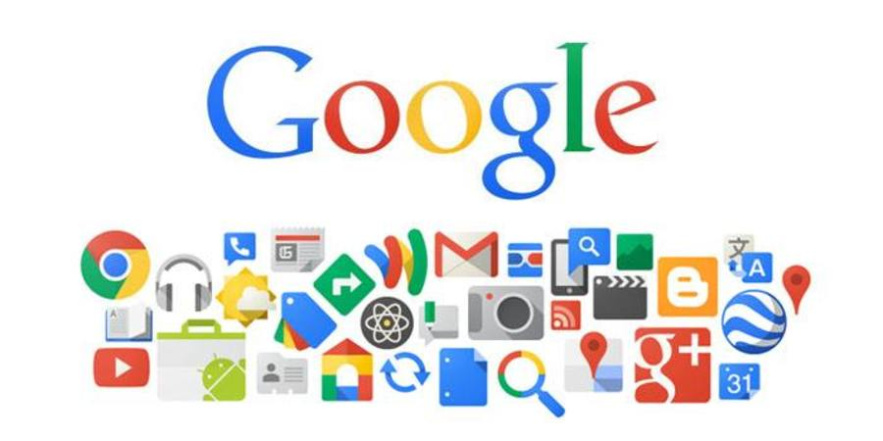

5



1. Gmail:

Gmail, Google's email platform, stands as a groundbreaking milestone in the ever-evolving landscape of electronic communication. Introduced to the digital realm in 2004, Gmail marked a paradigm shift in how individuals interact with their emails. Its inception not only brought a fresh perspective to email services but also revolutionized the entire user experience by introducing innovative features that set it apart.

Launched with forward-thinking features such as threaded conversations, Gmail discarded the traditional linear email structure, providing users with a more organized and coherent way to manage their communication. The introduction of powerful search capabilities elevated the efficiency of email retrieval, allowing users to locate specific emails swiftly and effortlessly. These features, combined with an intuitive user interface, created a seamless and user-friendly environment, catering to both tech-savvy individuals and those new to the digital landscape.

Over the years, Gmail has solidified its position as a global email giant, boasting a staggering user base exceeding one billion. This colossal user count is a testament to its widespread adoption and acceptance

6

among users across diverse demographics. The service's ubiquity underscores its relevance in meeting the diverse needs of individuals, businesses, and organizations worldwide

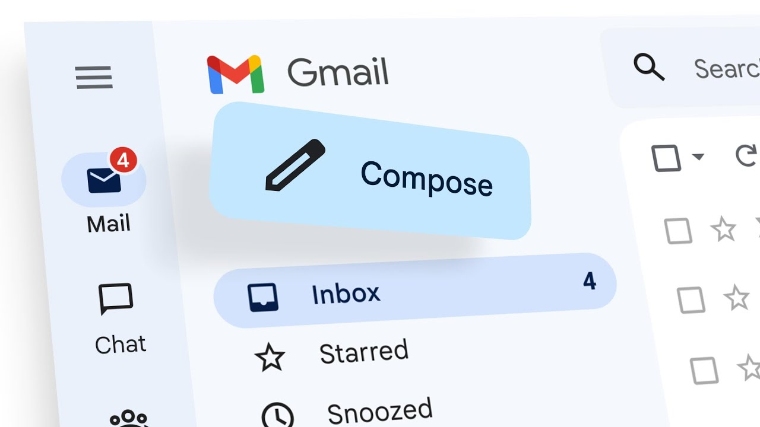

The success of Gmail goes beyond its user numbers; it has become a symbol of innovation and adaptability in the digital communication sphere. Its continuous evolution and incorporation of new features, such as smart categorization, priority inbox, and integration with other Google services, showcase its commitment to staying ahead of the curve in addressing the evolving needs of its users.

7



1. Maps :

Google Maps, unveiled in 2005, stands as a revolutionary force in the realm of navigation and location-based services, reshaping how individuals perceive and interact with geographical information. The introduction of features such as turn-by-turn navigation, real-time traffic updates, and immersive Street View imagery catapulted Google Maps beyond the realm of conventional mapping tools, transforming it into an essential companion for users worldwide.

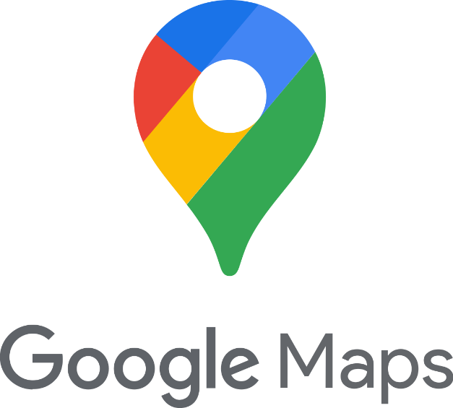The advent of turn-by-turn navigation marked a significant departure from traditional static maps, offering users dynamic, real-time guidance on their journeys. This feature, coupled with real-time traffic updates, not only revolutionized the daily commute but also empowered users to make informed decisions about their routes, optimizing travel time and enhancing overall navigation efficiency.

Furthermore, Street View imagery introduced a groundbreaking visual dimension to Google Maps, allowing users to virtually explore and familiarize themselves with locations before physically arriving. This immersive experience not only added a layer of realism to navigation but also proved invaluable for businesses seeking to showcase their physical presence and surroundings.

8



Beyond its utility for individuals, Google Maps has seamlessly integrated into the business landscape through Google My Business. This extension allows businesses to establish a digital presence on the platform, offering them visibility and accessibility to potential customers. From locating nearby establishments to exploring business information, Google Maps has become a go-to platform for users seeking both local and global services.

The profound impact of Google Maps extends far beyond providing directions; it has become a multifaceted tool influencing various aspects of modern life. Whether aiding in local exploration or facilitating global navigation, Google Maps remains at the forefront of location-based services, continually evolving to meet the dynamic needs of its diverse user base. As technology advances, Google Maps is poised to further redefine our relationship with the world around us, promising continued innovation and enhanced experiences in the ever-expanding landscape of digital navigation. 9



1. Calendar:

Google Calendar, introduced to the digital arena in 2006, stands as a formidable solution in simplifying the intricate task of scheduling and time management. Its inception brought about a paradigm shift in how individuals approach organizing their daily lives, offering a dynamic and user-friendly platform to seamlessly manage commitments. The robust features embedded within Google Calendar empower users to not only streamline their schedules but also enhance their overall productivity through strategic time management.

At its core, Google Calendar provides users with the ability to create and organize events, set reminders, and establish a coherent structure for their daily, weekly, or monthly activities. The intuitive interface facilitates effortless customization, allowing users to color-code events, set priority levels, and categorize commitments, providing a visual and comprehensive overview of their time commitments.

What sets Google Calendar apart is its seamless integration with other Google services, particularly Gmail. This synergy creates a holistic ecosystem where communication and scheduling intersect seamlessly. Events mentioned in Gmail emails automatically generate calendar entries, eliminating the need for manual data entry and ensuring that important commitments are not overlooked. This integration extends beyond mere convenience; it transforms Google Calendar into a powerhouse for both personal and professional time management.

10

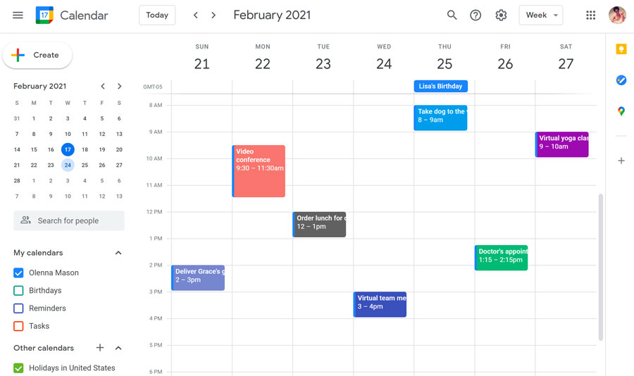

In the realm of personal productivity, Google Calendar acts as a virtual assistant, reminding users of impending deadlines, meetings, or social engagements. The interconnected nature of Google services ensures that the calendar becomes an integral part of the user's digital experience, facilitating a cohesive and efficient workflow.

In the professional sphere, the collaborative potential of Google Calendar shines through. The ability to share calendars with colleagues, set collaborative events, and synchronize schedules ensures seamless coordination within teams. This collaborative functionality, coupled with the accessibility of Google Calendar across multiple devices, fosters a cohesive work environment where teams can stay synchronized regardless of geographical locations.

In essence, Google Calendar transcends the traditional boundaries of a scheduling tool; it becomes a dynamic companion in the journey of personal and professional time management. As technology continues to evolve, Google Calendar remains at the forefront, adapting and innovating to meet the ever-changing needs of users in their quest for efficient, organized, and well-managed lives.

11



4.Chrome :

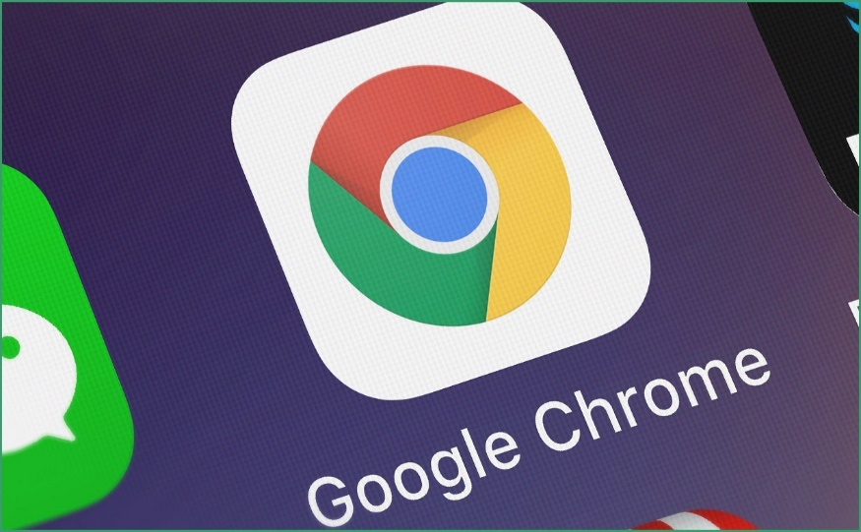Debuting in 2008, Google Chrome has positioned itself as a groundbreaking web browser, revolutionizing the digital landscape by establishing unparalleled standards in terms of speed, simplicity, and security. The browser's minimalist design, characterized by a clean and uncluttered interface, has not only contributed to a visually appealing user experience but has also played a pivotal role in streamlining navigation.

Beyond its aesthetic appeal, Google Chrome boasts a formidable set of features that have elevated it to a preferred choice for a substantial share of internet users globally.

The introduction of the Chrome Web Store has added an extra layer of functionality, providing users with a diverse array of extensions, apps, and themes that enhance their browsing experience. This marketplace, curated for Chrome users, facilitates customization and personalization, allowing individuals to tailor their browser to suit their specific needs and preferences.

12

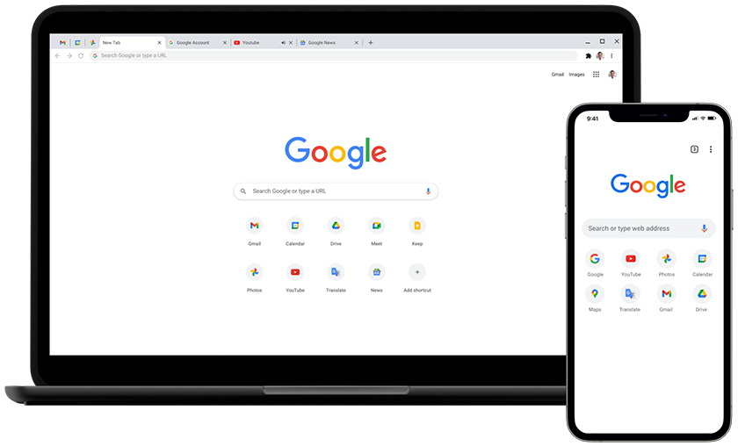

One of the standout features that contribute to Chrome's popularity is its synchronization capability across devices. This functionality ensures a seamless and consistent browsing experience across multiple platforms, enabling users to access their bookmarks, history, and preferences effortlessly, whether on a desktop, laptop, or mobile device. The synchronization feature not only enhances user convenience but also reflects Google Chrome's commitment to providing a cohesive and integrated web browsing experience in an increasingly interconnected digital landscape.

In the realm of security, Google Chrome has implemented robust measures to safeguard users from online threats. Its automatic updates and built-in phishing protection contribute to a safer browsing environment, addressing the ever-evolving challenges posed by cybersecurity threats. This dedication to security, coupled with regular updates, ensures that Chrome users benefit from the latest advancements in web security, reinforcing the browser's reliability.

13

As we navigate the dynamic digital era, Google Chrome continues to evolve, adapting to the changing needs and expectations of its vast user base. Its innovative features, commitment to security, and seamless synchronization across devices position it not just as a browser but as a comprehensive tool that caters to the diverse demands of the modern internet user. In setting new benchmarks for web browsers, Google Chrome remains a cornerstone of the digital experience for millions around the world.



5.Sheet :

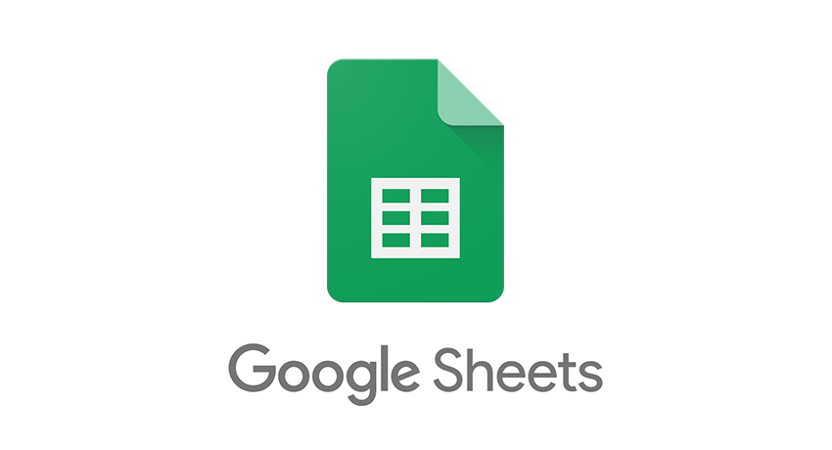

Introduced in 2006, Google Sheets has revolutionized collaborative data analysis by offering a cloud-based spreadsheet tool that transcends traditional limitations. The real-time editing feature is a game-changer, allowing multiple users to work on the same spreadsheet simultaneously, fostering seamless collaboration. This dynamic environment eliminates version control issues and streamlines the collaborative workflow, making it an ideal solution for teams.

Google Sheets goes beyond basic data entry with its powerful formulas, providing users with the capability to perform complex calculations and analyses effortlessly. Whether you're a novice or an advanced data analyst, the tool's versatility empowers users to derive meaningful insights from their data. The integration of robust formulas enhances the tool's analytical capabilities, positioning it as a valuable asset for a wide range of data-centric tasks.

15

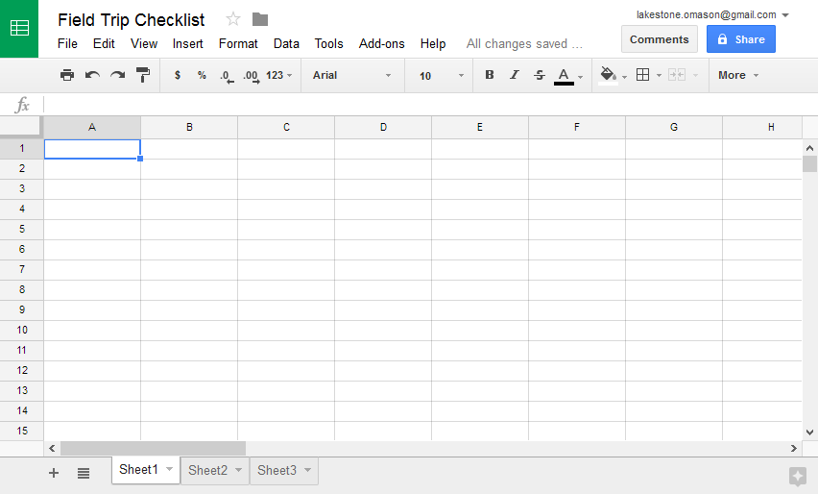

The platform's easy sharing options, coupled with customizable permission settings, simplify collaboration further. This feature is particularly crucial in a world where remote work and virtual collaboration have become the norm. Google Sheets facilitates effective collaboration by transcending geographical barriers, ensuring that teams can work together seamlessly, regardless of their physical locations. As businesses increasingly rely on data for decision-making, Google Sheets continues to be a cornerstone in driving efficiency, collaboration, and informed decision-making in the ever-evolving digital landscape.

16



6.Meet :

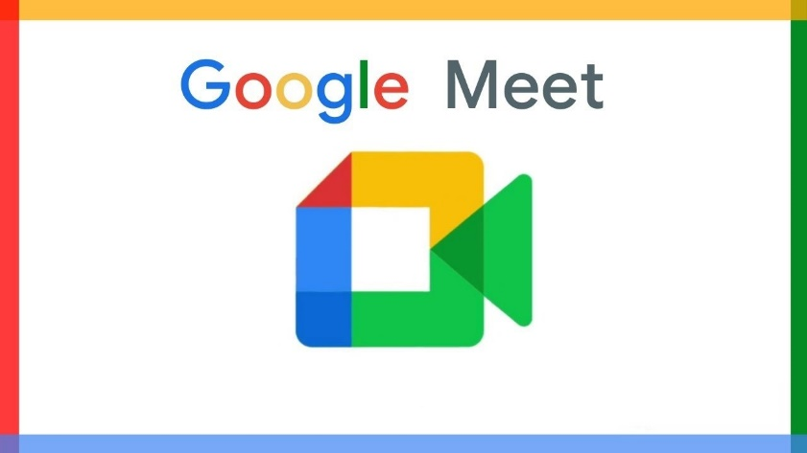

Google Meet, introduced in 2017, has gained prominence as a video conferencing solution. Particularly in the wake of the global shift to remote work, Google Meet has proven itself with features like high-quality video and audio, screen sharing, and integration with other Google services, including Calendar.

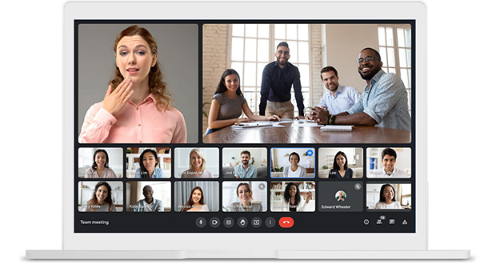

17



7.Classroom :

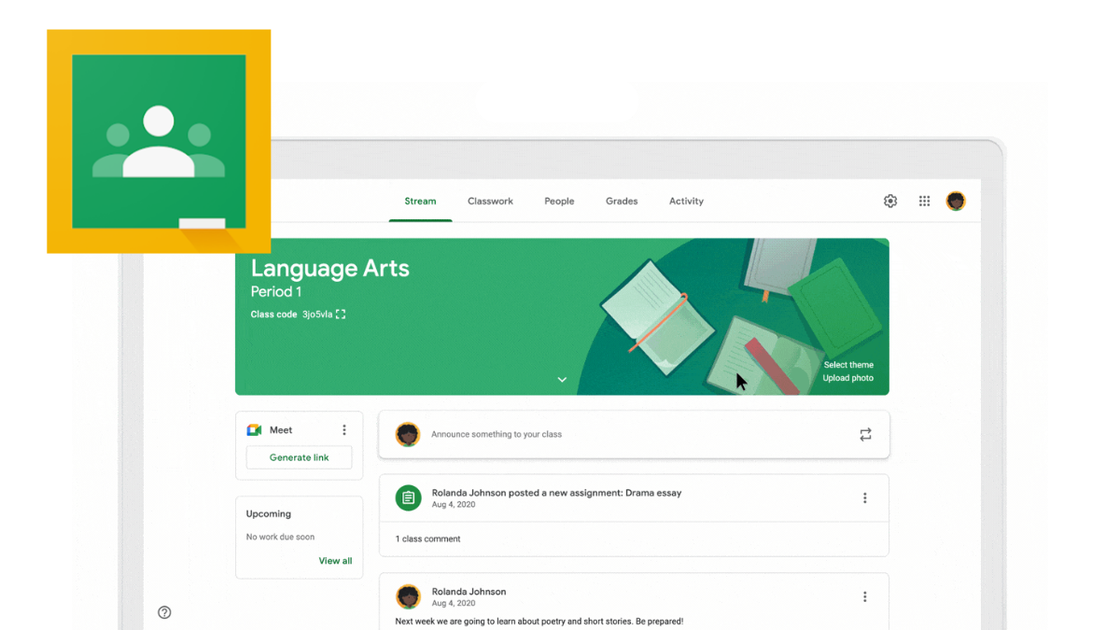

Google Classroom, launched in 2014, has become a cornerstone in the realm of online education. It provides a centralized platform for educators to create and manage classes, distribute assignments, and engage with students. Especially in the context of remote and hybrid learning, Google Classroom has facilitated seamless communication and collaboration in educational settings.

18



8.Drive :

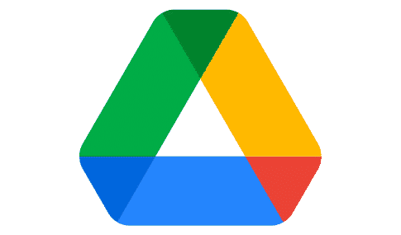Launched in 2012, Google Drive has redefined cloud storage and file-sharing, emerging as a pivotal solution in the digital era. This cloud-based platform transcends traditional storage methods, providing users with a seamless and secure repository for their digital content. Its integration with other Google services, including Docs, Sheets, and Slides, amplifies collaborative work by enabling real-time editing and version control, fostering a dynamic and efficient workflow for teams.

The collaborative capabilities of Google Drive set it apart, allowing multiple users to work on the same document simultaneously. Real-time editing ensures that changes are instantly visible to all collaborators, eliminating version conflicts and enhancing overall productivity. This interconnected approach transforms Google Drive into more than just a storage solution; it becomes a central hub for collaborative creation and efficient document management.

Google Drive's versatility makes it an indispensable tool for both individuals and businesses. Its secure and accessible cloud storage ensures that digital content is safeguarded while remaining readily available for users. As businesses increasingly adopt remote work and collaborative practices, Google Drive's role as a secure, collaborative, and accessible repository for digital content continues to solidify, contributing to the evolving landscape of digital productivity.

19



Uses of Google Services:

The versatile applications of Google services span a myriad of scenarios, significantly impacting various aspects of personal and professional life.

Personal Productivity: Google services enhance personal productivity by providing intuitive tools for communication, organization, and information management. Gmail streamlines email communication, Calendar helps individuals manage their schedules effectively, and Drive offers a secure repository for personal documents.

Collaborative Work Environments: In professional settings, Google services foster collaborative work environments. Google Drive, with its real-time editing and sharing capabilities, facilitates seamless teamwork on documents, spreadsheets, and presentations. Google Meet and Classroom contribute to effective communication and collaboration, bridging geographical gaps in the modern workplace.

Education:Google services have become integral to the field of education. Google Classroom revolutionizes the way educators create and manage courses, while tools like Docs and Sheets provide students with collaborative platforms for assignments and projects. The accessibility of these services has played a crucial role in supporting remote and online learning initiatives.

20

Business Solutions: Businesses leverage Google services for streamlined operations and enhanced productivity. G Suite (now Google Workspace) offers a suite of tools for business communication, collaboration, and document management. Google My Business utilizes Maps to enhance the online presence of businesses, providing a platform for customer interaction and reviews.

21



Microsoft office tools



Microsoft office tools:

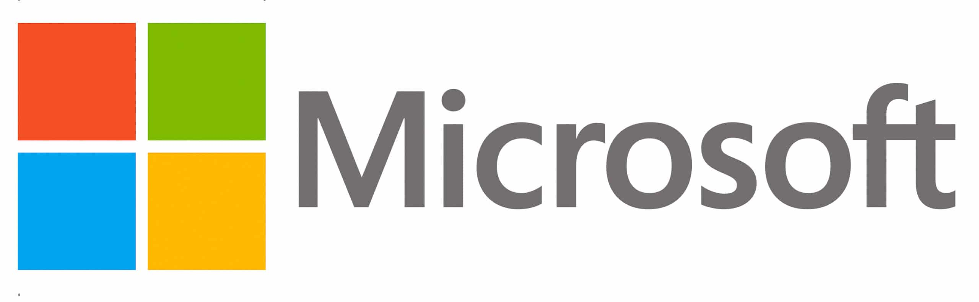

Microsoft Tools are a type of application software . They help the users to perform tasks easily and efficiently. Therefore, these tools help to create, manage, and manipulate large amounts of data and documents. Moreover, they help create presentations, reports, databases, etc. Hence, users can perform such tasks repeatedly with less time and effort. These tools include software such as word processors, presentation tools, spreadsheets database systems, email tools, etc.

22

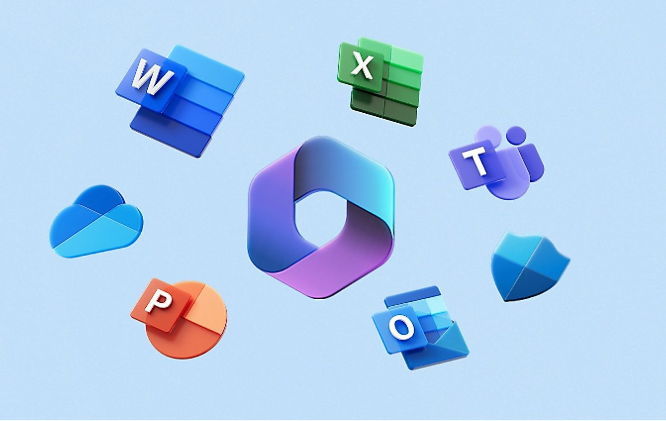

Microsoft Tools are a type of application software . They help the users to perform tasks easily and efficiently. Therefore, these tools help to create, manage, and manipulate large amounts of data and documents. Moreover, they help create presentations, reports, databases, etc. Hence, users can perform such tasks repeatedly with less time and effort. These tools include software such as word processors, presentation tools, spreadsheets database systems, email tools, etc.

23



1.Word



"Word" is the flagship software of the Microsoft office suite. It is one of the most used software in the world and allows you to write letters, CVs, reports and all types of text documents. Word allows you to layout your documents, generate summaries, automatically number pages, correct grammar and spelling, create diagrams, do mail merges, etc.

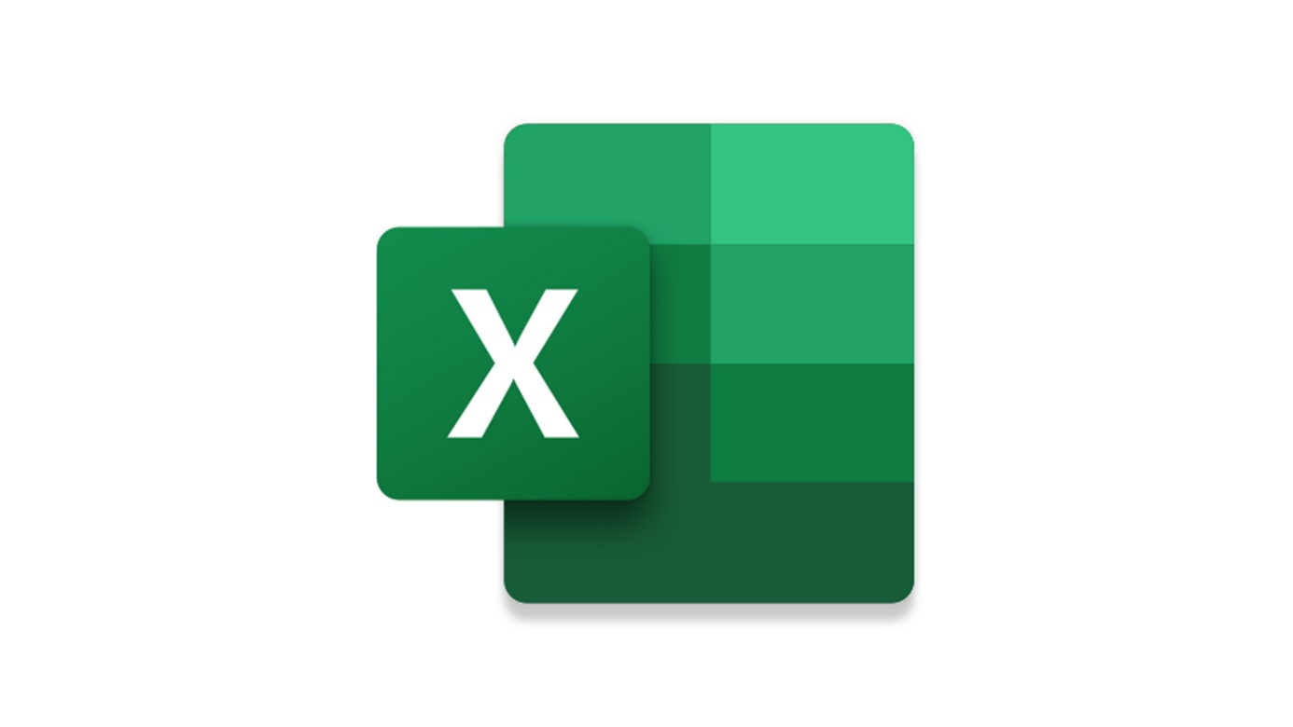2.Excel

"Excel" is spreadsheet software from the Microsoft Office suite. It is intended to run on Microsoft Windows , Mac OS X , and Android operating systems. It integrates numerical calculation , graphical representation , data analysis and programming functions , which uses macros written in the VBA ( Visual Basic for Applications ) 2 language.

24



3.Powerpoint

"PowerPoint" is presentation software published by Microsoft. It is part of the Microsoft Office suite. It works on Windows and Mac OS. It allows you to create slideshows containing "slides." It actually allows you to create a succession of blank pages in the format of a 4/3 screen (the slides) in which objects, images, texts, videos and graphics are placed. The term slide comes from photo slides, made obsolete by the use of PowerPoint presentations. Presentations can be projected via a video projector, viewed on a computer screen, printed, exported for viewing on a web page , etc.

25



4.Publisher

Publisher is desktop publishing (DTP) software published by Microsoft.

It allows you to produce semi-professional quality communication documents.

It offers multiple functions:

-for creating and formatting documents: multiple wizards, layout format , templates;

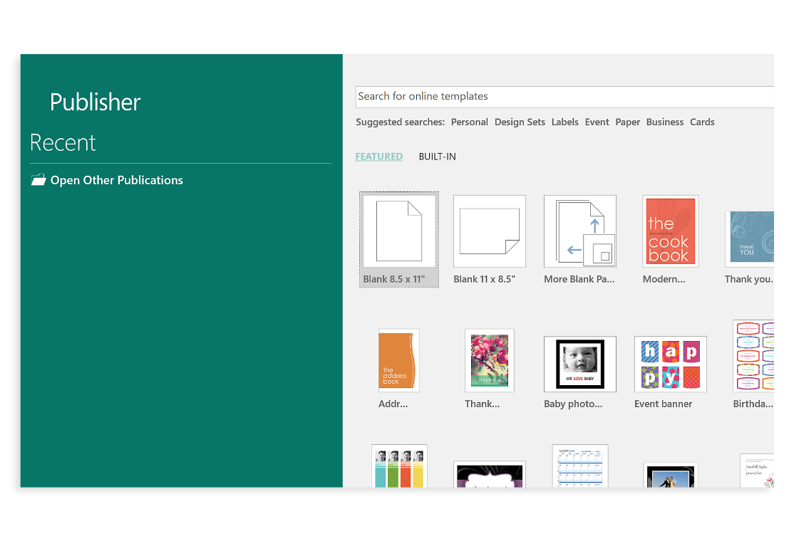 -multimedia integrations with images, videos, sounds and animations.

26



4.Access

"Access" is a relational database published by Microsoft. It is composed of several programs: the Microsoft Jet database engine , a graphical editor, a Query by Example interface for querying databases, and the Visual Basic for Applications programming language. Access interface has made it possible to graphically manage collections of data in tables, to establish relationships between these tables according to the usual rules of relational databases, to create queries with QBE, to create human/machine interfaces and print reports.

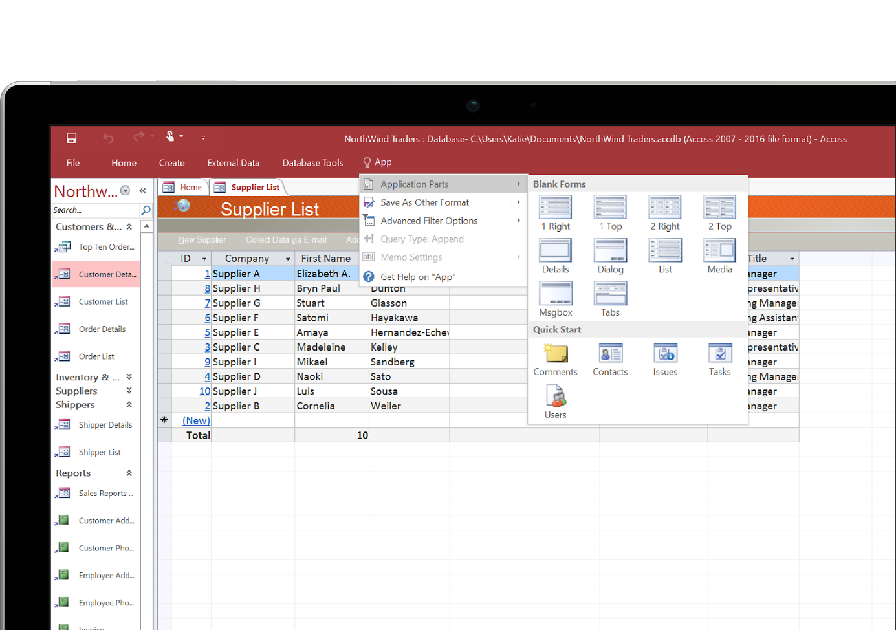

27



4.Project

"Project" is project management software published by Microsoft . It allows project managers and planners to plan and manage projects, manage resources and budget, as well as analyze and communicate project data.



5.Outlook

"Outlook" is a proprietary personal information manager and email client published by Microsoft. It also allows you to manage groups whose members are part of the same project, department, service or simply the same company or organization.Although it is primarily used as an email application , it also offers a calendar and a task and contact manager.

28



6.Azure

"Azure" is Microsoft Azure is a set of cloud computing services offered by Microsoft for businesses and developers. It allows you to develop, test, deploy and manage applications and services using Microsoft tools and technologies. It includes services such as virtual machines , storage , database, application development, data analytics, Internet of Things, networking and cybersecurity. It can also be used to manage hybrid applications, that is, applications that run both in the cloud and on local computers.



29



7.Onedrive

As for the online function we have "Onedrive" is a set of online services: storage and applications Word , Excel , PowerPoint and OneNote , the functionality of which is however reduced compared to software installed on a computer. The service can be used in two ways: through a web browser , by downloading files to a server , retrieving them on your computer if necessary and sharing them with friends or with all Internet users; or through the OneDrive software which allows synchronization between OneDrive and compatible computer media.

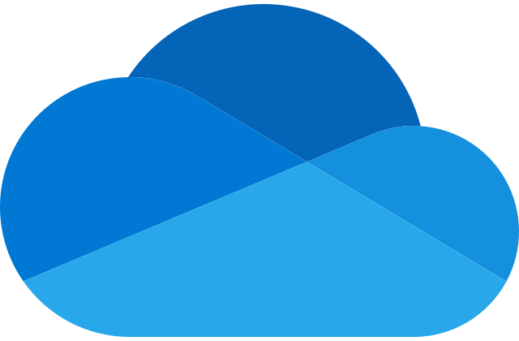

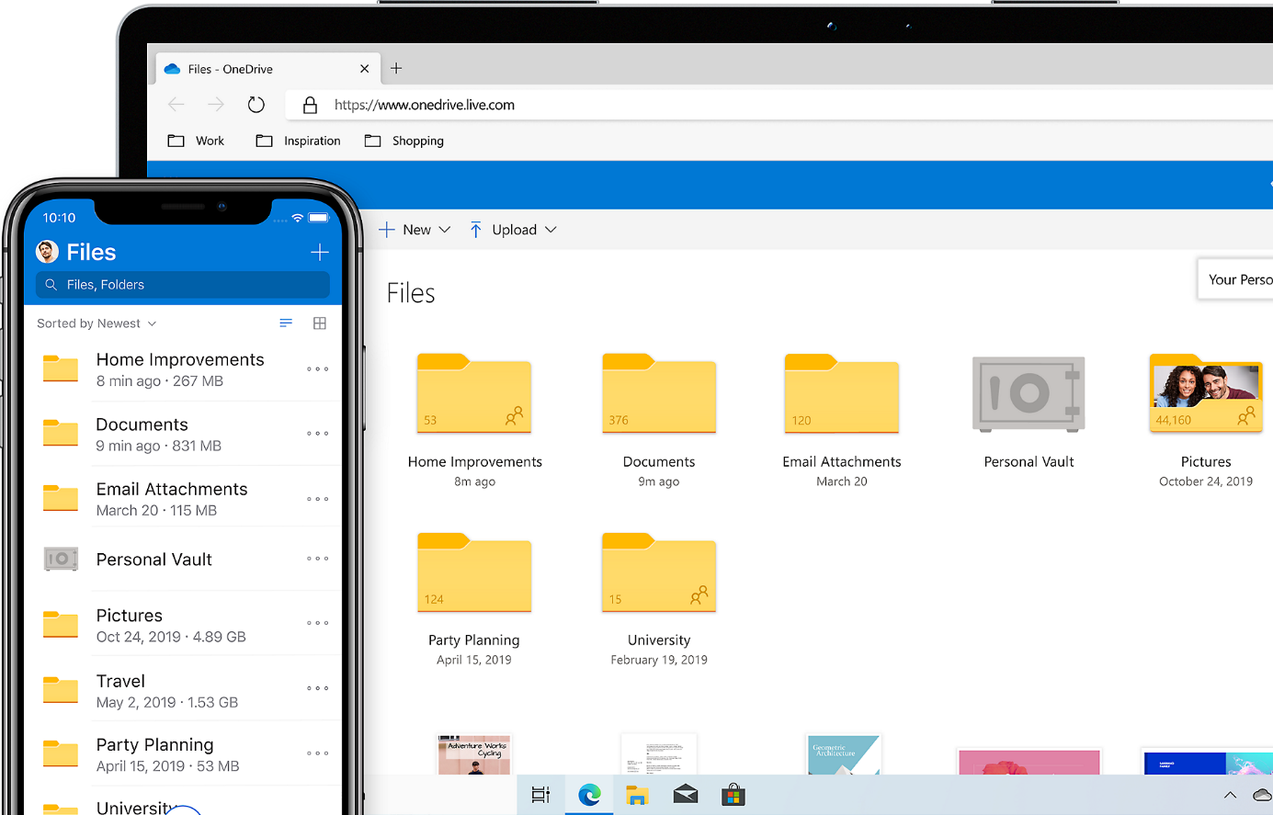

30

7.Microsoft teams

Microsoft Teams: Microsoft also has a collaborative communication application which integrates with the Microsoft 365 suite to replace Skype for Business and offers extensions that can be integrated into products other than those from Microsoft. It is currently available in 181 countries and is translated into 25 languages. And we call it "Teams"

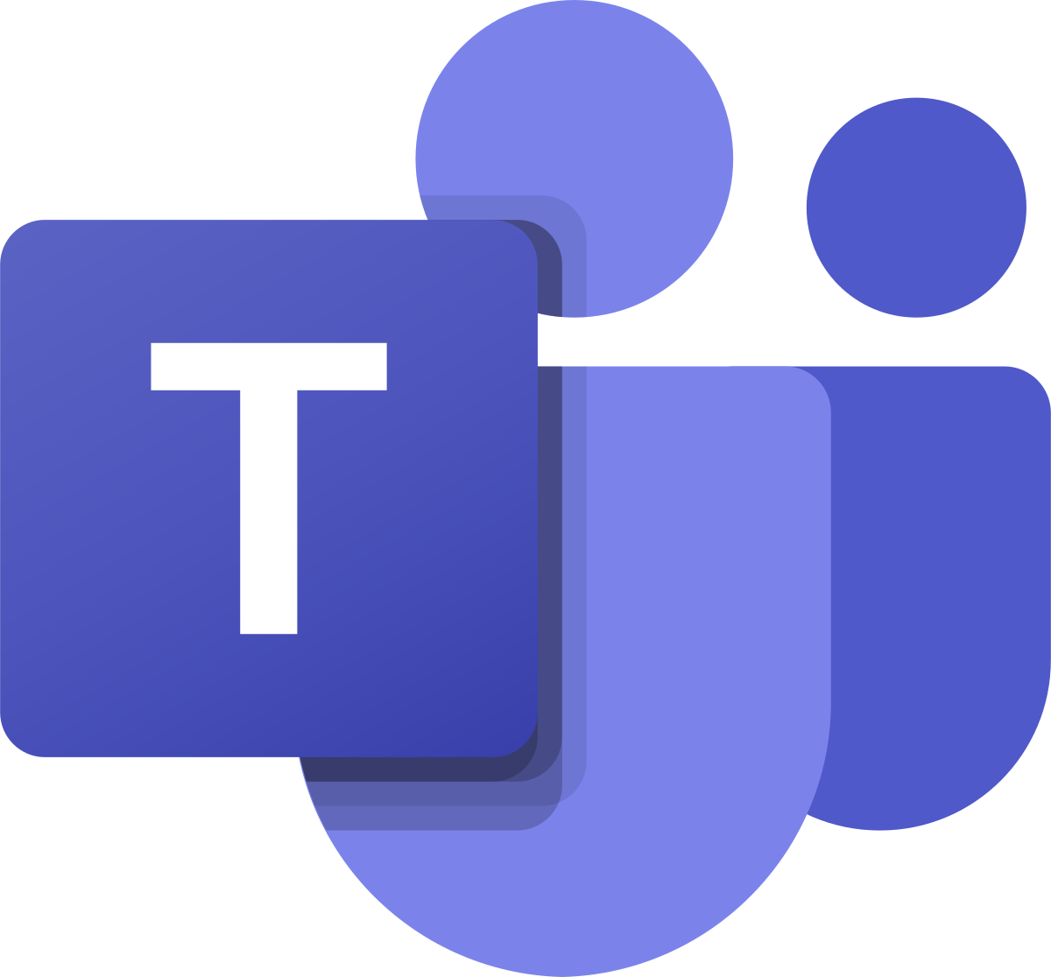

31



Git/Github



Git

Git is a distributed version control system that tracks changes in source code during software development. It allows multiple developers to collaborate on a project, managing revisions and facilitating efficient code integration. Git enables branching, merging, and history tracking to enhance collaboration and code management.



32



Github

GitHub is a web-based platform that utilizes Git for version control and collaborative software development. It provides a centralized hub for hosting and sharing code repositories, enabling multiple developers to collaborate on projects. GitHub offers features like issue tracking, pull requests, and project management tools to streamline the development process

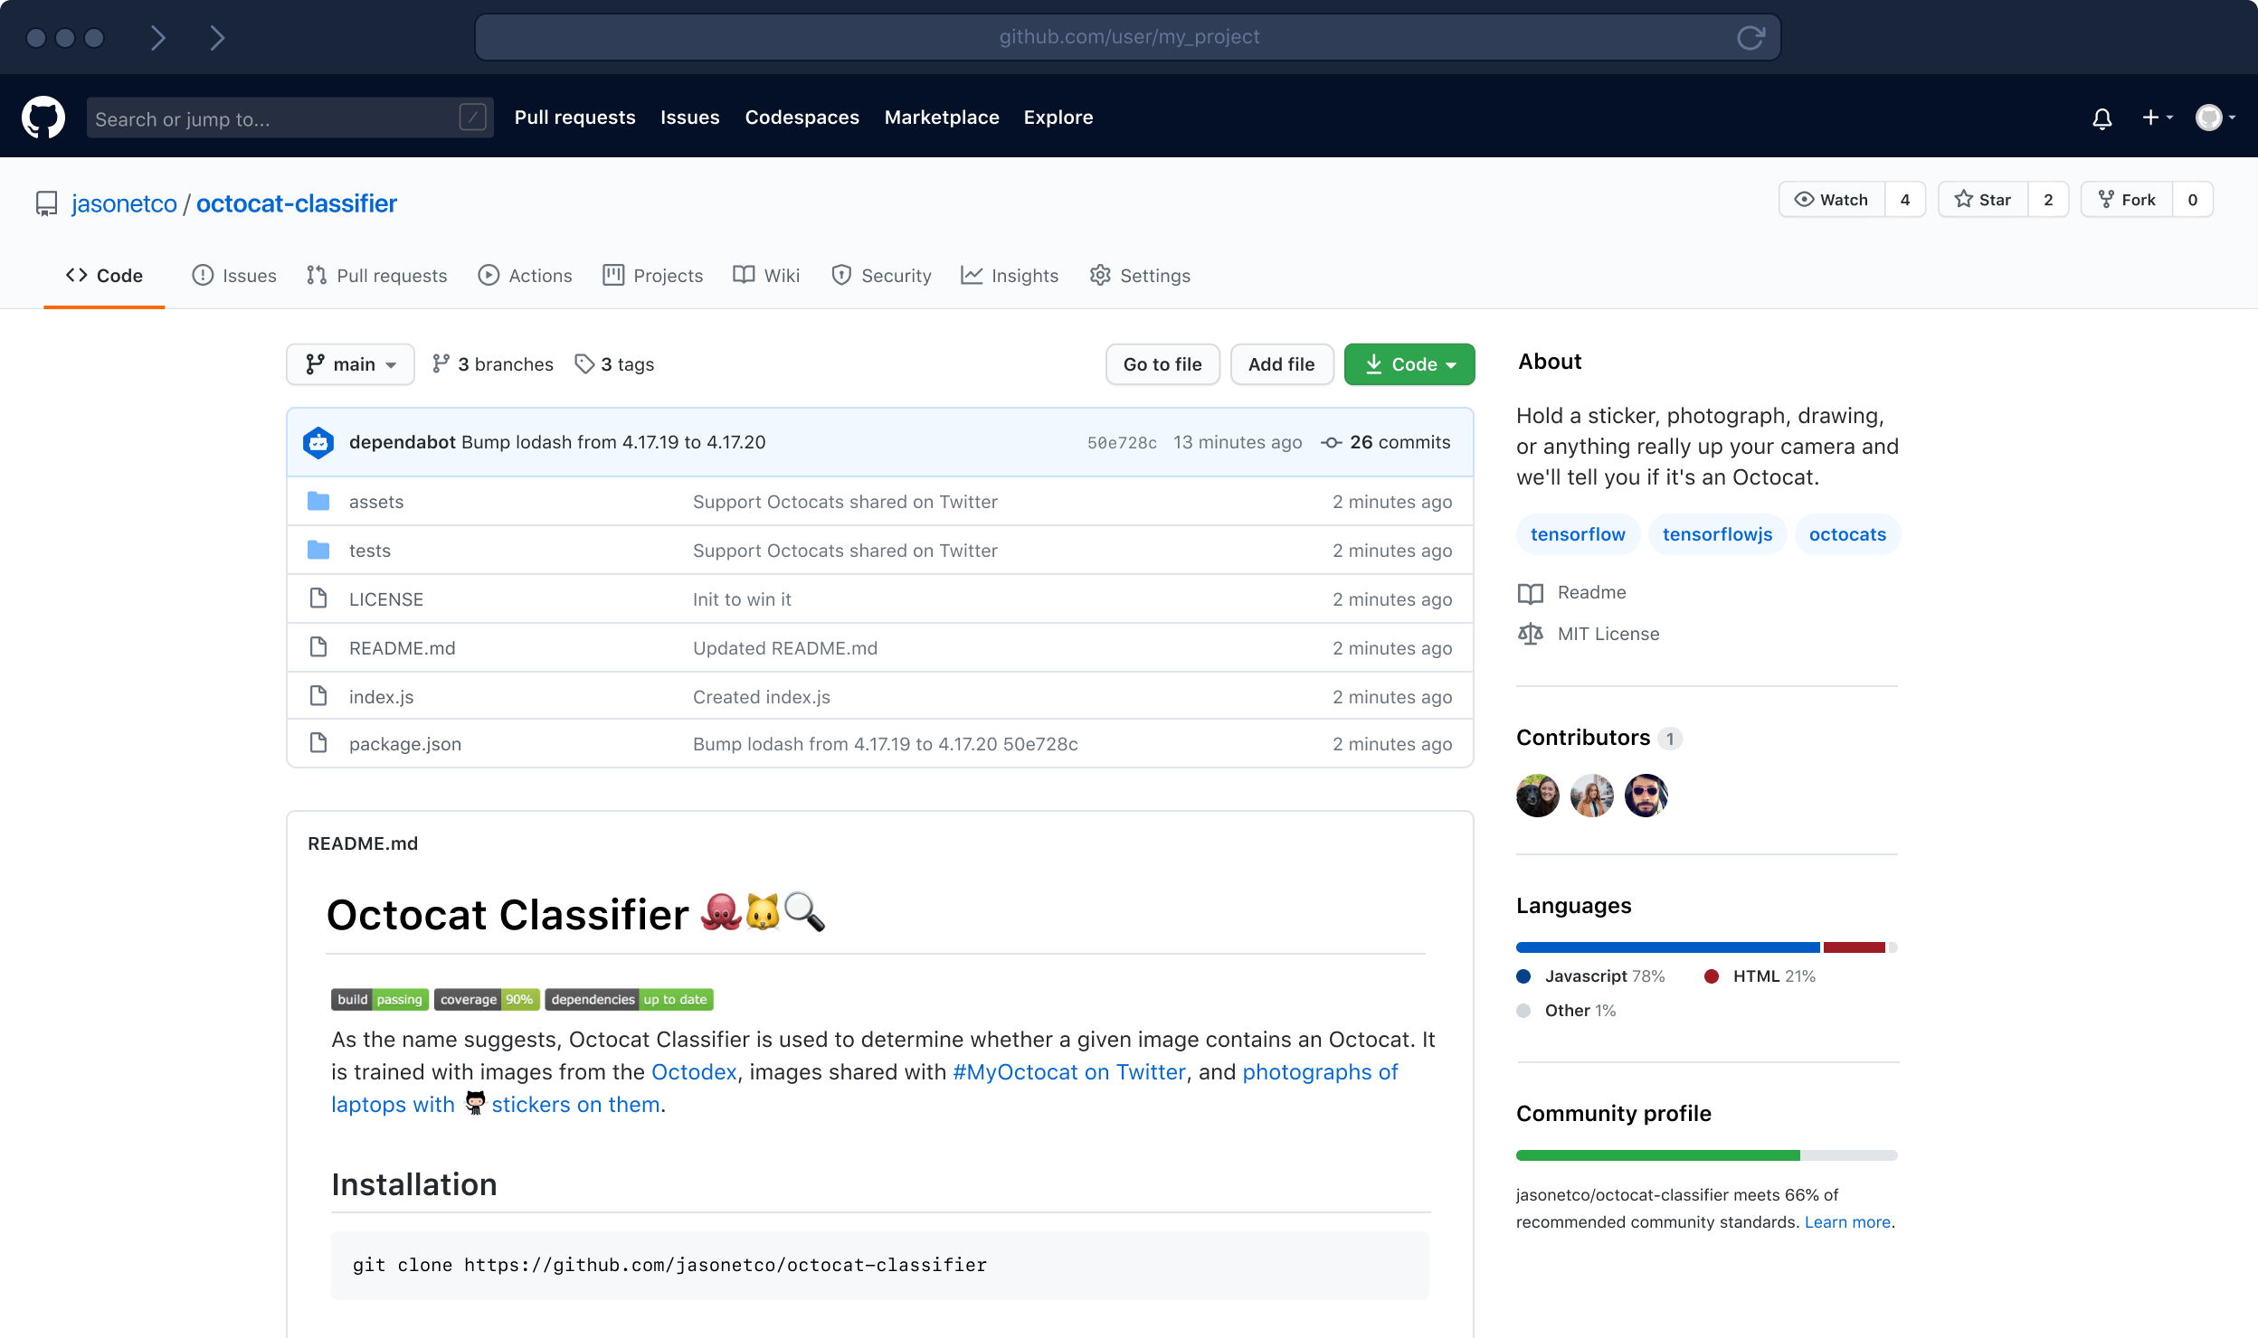



Git VS Github

|  |  |
| --- | --- |
| What is GitHub? — Pythia Foundations | Fichier:Git icon.svg — Wikipédia |
| 1. It’s a service.  2. It’s hosted on  web.  3. It provides a graphical  interface.  4. It’s a space to upload a  copy of the git  repository.  5. It provides functionalities of  Git like VSC, Source Code  Management as well as adding  few of its own features. | **1. It’s a software.**  **2. It’s installed locally on the**  **system.**  **3. It’s a command line**  **Tool.**  **4. It’s a Tool to manage different**  **versions of edits, made to files**  **in a git repository.**  **5. It provides functionalities like**  **Version Control System, Source**  **Code Management.** |

34



**Conclusion**



Conclusion

Information and communication technologies (TIC) have

revolutionized global connectivity, communication, and economic

growth. Key components like data management and cybersecurity play

vital roles. TIC&#39;s ongoing evolution presents challenges and

opportunities, demanding adaptive responses. Ultimately, TIC has

become integral to our socio-economic fabric, shaping the way we live

and work, with continuous advancements shaping the future

technological landscape.

35



References

**Book:**

Information Technology for Management&quot; by Efraim Turban, Linda Volonino, and Gregory R. Wood

Information Systems: A Manager’s Guide to Harnessing Technology by John Gallaugher

**Website:**

-IEEE Computer Society: The IEEE Computer Society is a professional organization for computing professionals. Their website (https://www.computer.org/) provides access to a wealth of resources on various aspects of ICT.

- Association for computing Machinery (ACM): ACM (<https://www.acm.org/>) is a leading professional organization in the computing field. Their Digital Library is a valuable resource for research papers and articles.

**Conferences:**

- International Conference on Information and Communication Technologies (ICT): An annual conference that covers a wide range of topics related to ICT.

-International Conference on information Systems (ICIS): A premier conference in the field of information systems.

36

**Online Courses:**

-Platforms like Coursera, edX, and Udacity offer courses on various aspects of ICT. Look for courses from reputable institutions and instructors.

37